(YOUR LOGO/ADDRESS/HEADER HERE)

Happy Holidays from (YOUR COMPANY)!
As a valued patient using one of our many products, we are pleased to be offering a Holiday Special price on QUADRASTEPS® Foot Orthotics! As you know, QUADRASTEPS® orthotics are a great way to achieve custom orthotic results at a much more reasonable price! QUADRASTEPS® are available in standard and dress/narrow width versions. Dress/Narrow QUADRASTEPS® are slimmer and still provide excellent control and support while allowing you to have more choices in shoes. Keep an extra pair for your dress shoes, boots, and athletic shoes so you don’t have to switch them out – less wear and tear!
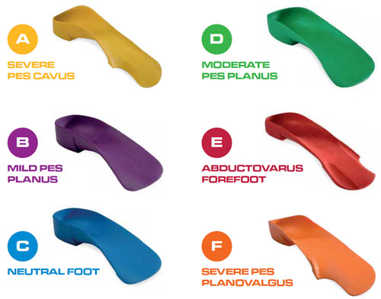
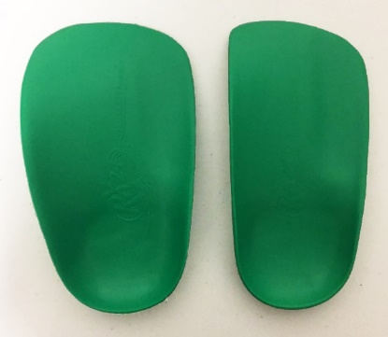
QUADRASTEPS® HOLIDAY SPECIAL
(offer expires 12/31/18)
Buy 1 pair QUADRASTEPS® for $____ ea.
(normally $____)
Buy 2 pairs of QUADRASTEPS® for $____ ea. (for yourself or for a family member** – can be two different models!)
Full length topcovers can be added to any QUADRASTEPS® for only $____ (Normally $____).
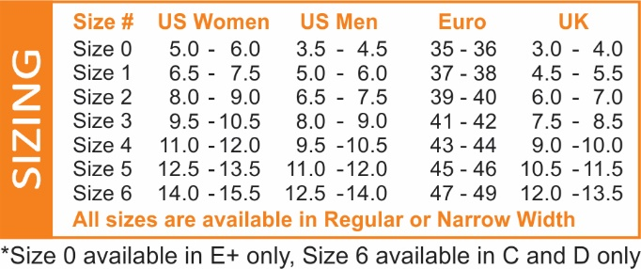
Stop by our (LOCATION) office and ask for the Holiday Special on
QUADRASTEPS®. Or for your convenience, QUADRASTEPS® can be
shipped directly to you for $______ extra.

Wishing you the best of health always!
The Doctors and Staff at (YOUR COMPANY)
Name:_____________________________
Address:___________________________
City:______________________________
State: __________ Zip: ______________
Card Type: MC Visa Amex Discover
Card #:____________________________
Exp date: ____________ CCV: _________
Billing Street: _______________________
Billing Zip: _________________________
*CCV security code is the last 3 digits on the back of your credit card in the signature box
(Your Address)
ORDER FORM
MODELS: A (YELLOW) B (PURPLE) C (BLUE) D (GREEN) E (RED) F (ORANGE)
SIZES: 1 2 3 4 5 6 (IF UNSURE, PLEASE INDICATE YOUR AVERAGE SHOE SIZE)
1ST PAIR: MODEL: ______ SIZE:_________ TOPCOVER: Y N PRICE: $_____ ea.
2ND PAIR: MODEL: ______ SIZES:________ TOPCOVER: Y N PRICE: $_____ ea.
3RD PAIR: MODEL: ______ SIZES:________ TOPCOVER: Y N PRICE: $_____ ea.
4th PAIR: MODEL: ______ SIZES:________ TOPCOVER: Y N PRICE: $_____ ea.
5+ PAIR: $_____ ea.
Please indicate the models you wish to purchase: (EX: A quad (yellow) – Size 4)
*If you already have a pair, look on the bottom of the heel for the model and size, ex: A4
** If you do not know your model, call our office for a free 15 minute screening before
to determine your correct model and size. Families Welcome!!!!
FILL OUT THIS FORM AND FAX TO ________; PHONE ________; OR JUST STOP IN!!
(YOUR LOGO/ADDRESS/HEADER HERE)

Happy Holidays from (YOUR COMPANY)!
As a valued patient using one of our many products, we are pleased to be offering a Holiday Special price on littleSTEPS® Foot Orthotics for Kids! As you know, littleSTEPS® orthotics are a great way to achieve custom orthotic results at a much more reasonable price! littleSTEPS® are firm yet comfortable to enforce foot alignment. Keep an extra pair for dress shoes, boots, and athletic shoes or cleats so you don’t have to switch them out – less wear and tear!
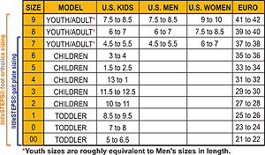
littleSTEPS® HOLIDAY SPECIAL
(offer expires 12/31/18)
Buy 1 pair littleSTEPS® for $____ ea.
(normally $99)
Buy 2 pairs of littleSTEPS® for $____ ea.
Buy 3 or more pairs littleSTEPS® for $____ ea.
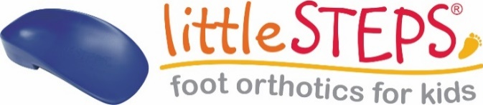

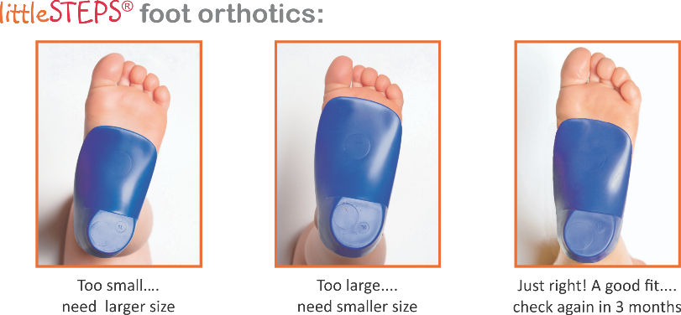

Stop by our (LOCATION) office and ask for the Holiday Special
on littleSTEPS®. Or for your convenience, littleSTEPS® can be
shipped directly to you for $______ extra.

Wishing you the best of health always!
The Doctors and Staff at (YOUR COMPANY)
Name:_____________________________
Address:___________________________
City:______________________________
State: __________ Zip: ______________
Card #:____________________________
Exp date: ____________ CCV: _________
Billing Street: _______________________
Billing Zip: _________________________
*CCV security code is the last 3 digits on the back of your credit card in the signature box
ORDER FORM
MODELS: littleSTEPS® foot orthotics for kids
SIZES: 00 00 1 2 3 4 5 6 7 8 9
IF UNSURE, INDICATE SHOE SIZE:___________
1ST PAIR: SIZE:____________ PRICE: $_____ ea.
2ND PAIR: SIZES:___________ PRICE: $_____ ea.
3+ PAIR: SIZES:___________ PRICE: $_____ ea.
*If you already have a pair, look on the bottom of the heel for the size (EX: LS00)
** If your family member has not been evaluated and fitted, call our office for a free
15 minute screening before to determine your correct model and size.
Families Welcome!!!!
FILL OUT THIS FORM AND FAX TO ________; PHONE ________; OR JUST STOP IN!!
FILL
(Your Address)

